Project report of
Bright Ideas Consulting.
1.Introduction
1.1. Overview a brief description about your project.
1.2. Purpose the use of this project. What can be achieved using this.
2.Problem Definition & Design Thinking
2.1. Empathy map paste the empathy map screenshot.
2.2. Ideation & Brainstorming map paste the ideation &brainstorming map screenshot.
3.Result
Final findings (Output) of the project along with screenshot.
4.Advantages & Disadvantages
List of advantages & disadvantages of the proposed solution.
5. Applications
The areas where this solution can be applied.
6.Conclusion
Conclusion summarizing the entire work and findings
7.Future Scope
Enhancements that can be made in the future.
8.Appendix
Source code attach the code for the solution built.

1.Introduction:
1.1.Overview a brief description about your project
Our project title is Bright Ideas Consulting. Bright Ideas Consulting is a service oriented firm. Consultants are people who are trained in recognizing problems and shaping solutions to those problems. This training is founded on a successful work career that has developed skills and maturity within the individual.
Like most professions though, these possessed skills must be focused and honed to apply the challenges of consulting to a variety of businesses. Successfull consultants continually study and learn their craft.
As a Certified Business Advisor, I have participated in continually adding information and training to my current experience to provide the most comprehensive base of knowledge available to the business of
our clients. Bright Ideas Consulting have years of experience in the areas of:
- Project Management
- Business process improvement
- Financial Analysis
- Communication,Training & Development
- Customer Service and improving the customer experience
- Policies & Procedures documentation and training
- Human Resources
- Marketing
Our company is built on the principles of creating long term professional relationshps with our clients and providing reliable service for years to come.
We want to be your personal Business Advisor. A person you trust and rely on in both the good times and the difficult ones. We want to be with you and your business through the growth, the challenges and the celebration of victory.
Our unique service has established our place in this industry. This allows us to make a distinctive and substantial impact for our client.
1.2.Purpose:
Bright Ideas Consulting ,a consulting firm uses Zoho books to effectively manage their financial processes, maintain accurate records, and make informed financial decisions. It offers leadership on an interim or short term basis to drive delivery of your development program and goals. Zoho books is an online accounting application that takes care of the accounting needs of your business.
2.Problem definition & design thinking
2.1. The Empathy map screenshot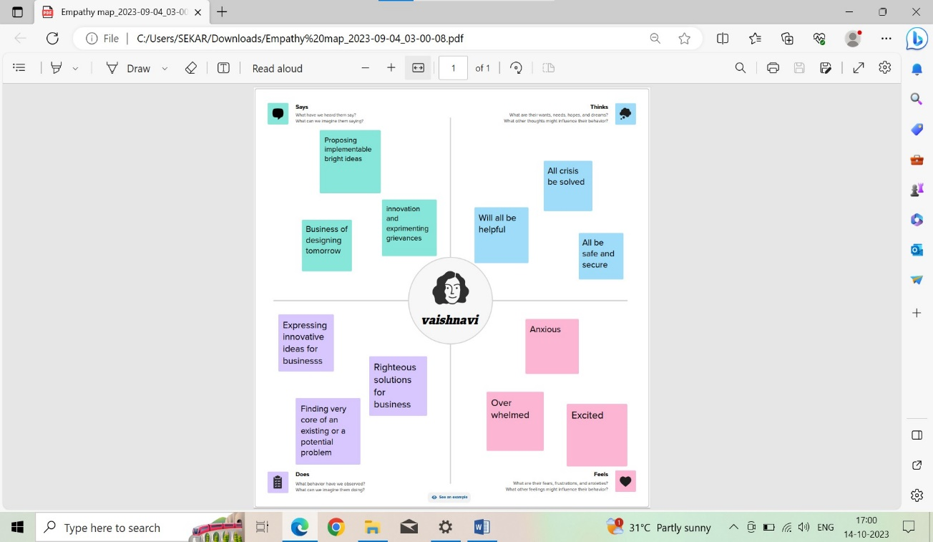
2.2. Ideation & brainstorming map screenshot
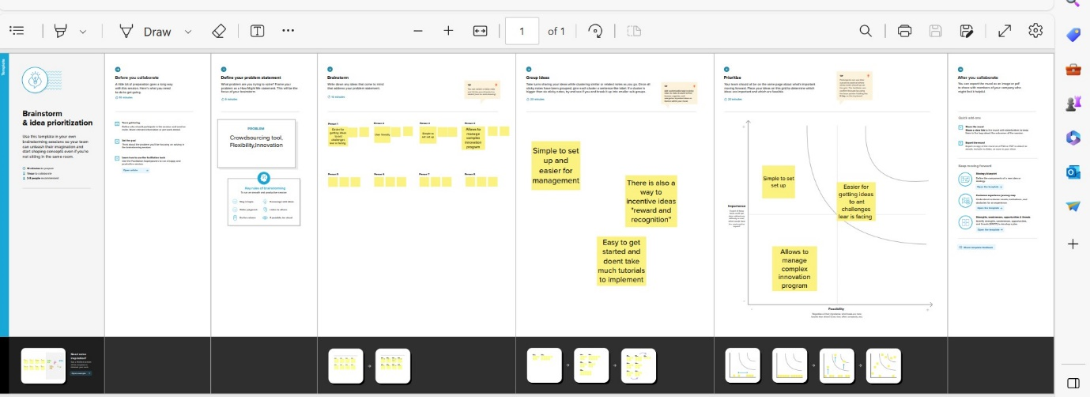
3.Result
Final finding (Output) of the project along with screenshots
3.1. GST Report:
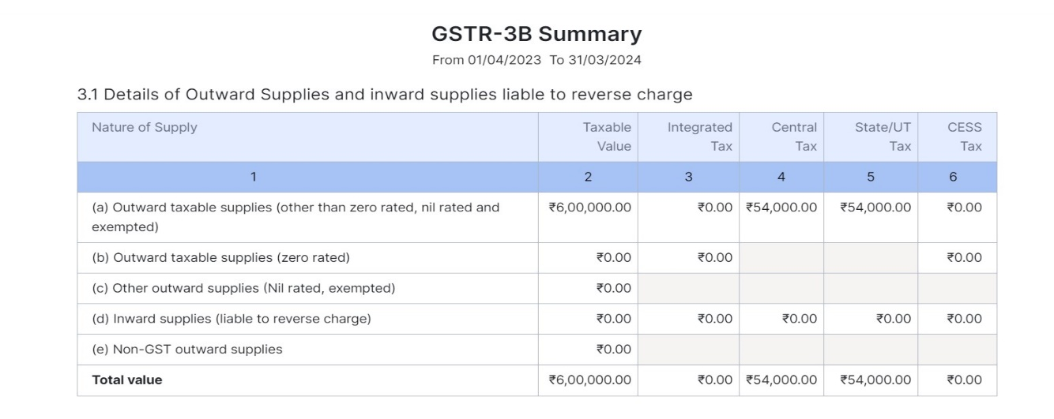
3.2. Aging Receivable summary:
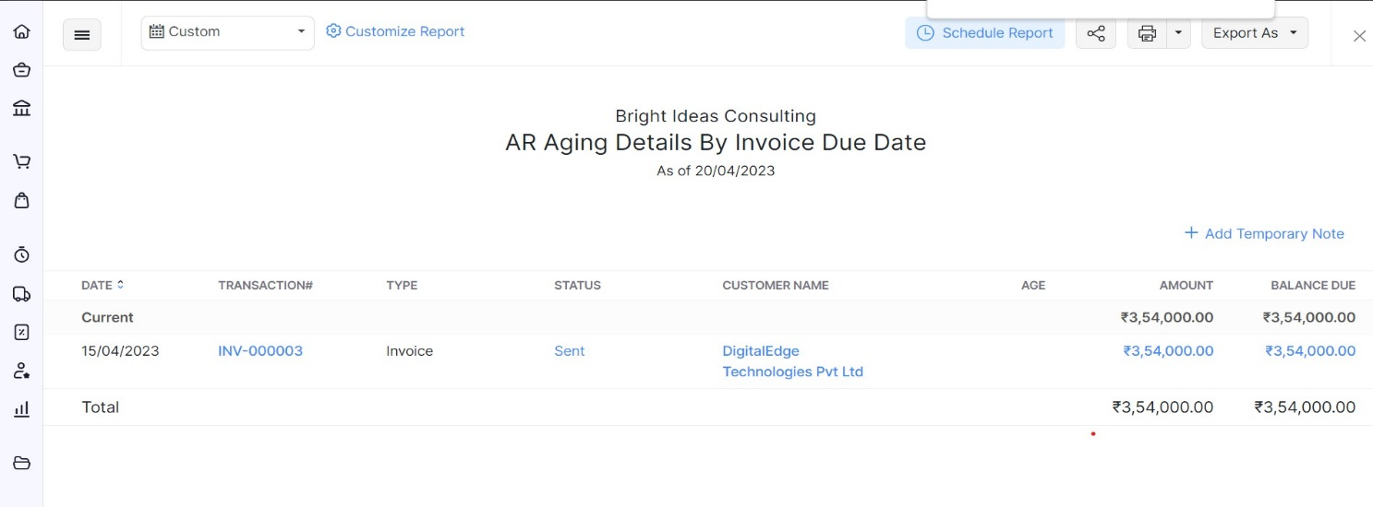
3.3. Aging Payables summary:
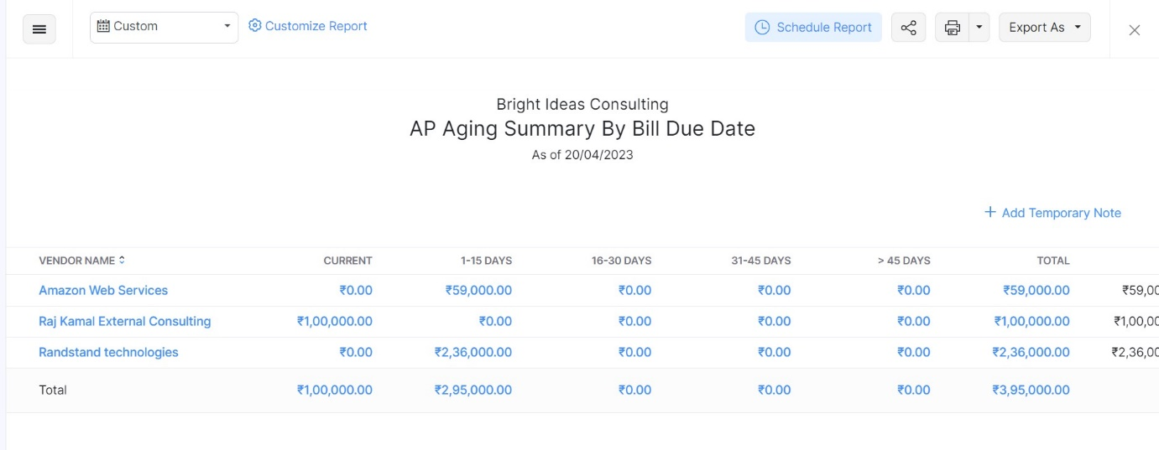
3.4. Items:
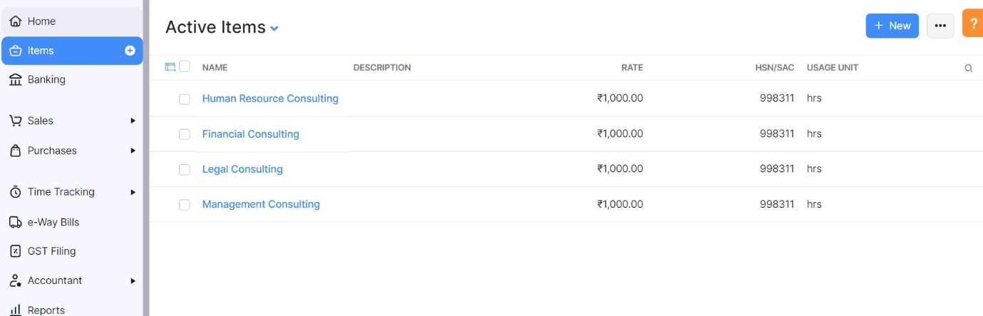
3.5. Sales Invoice:
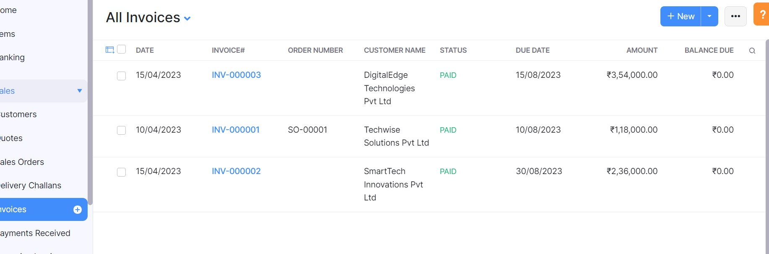
3.6. Purchase bills:
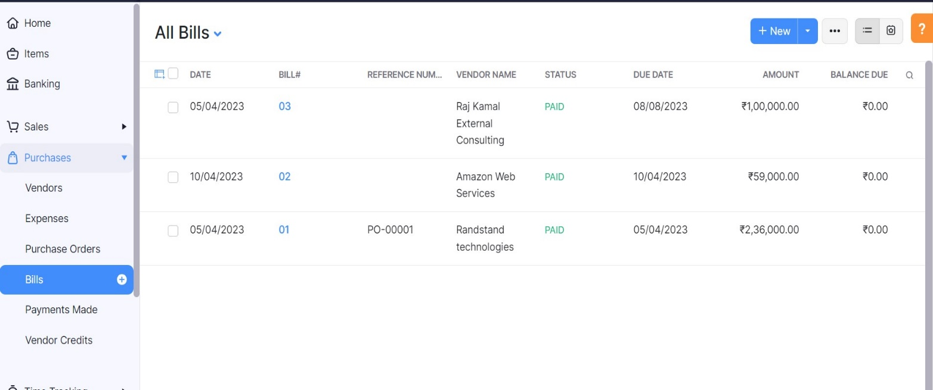
3.7. Customer:
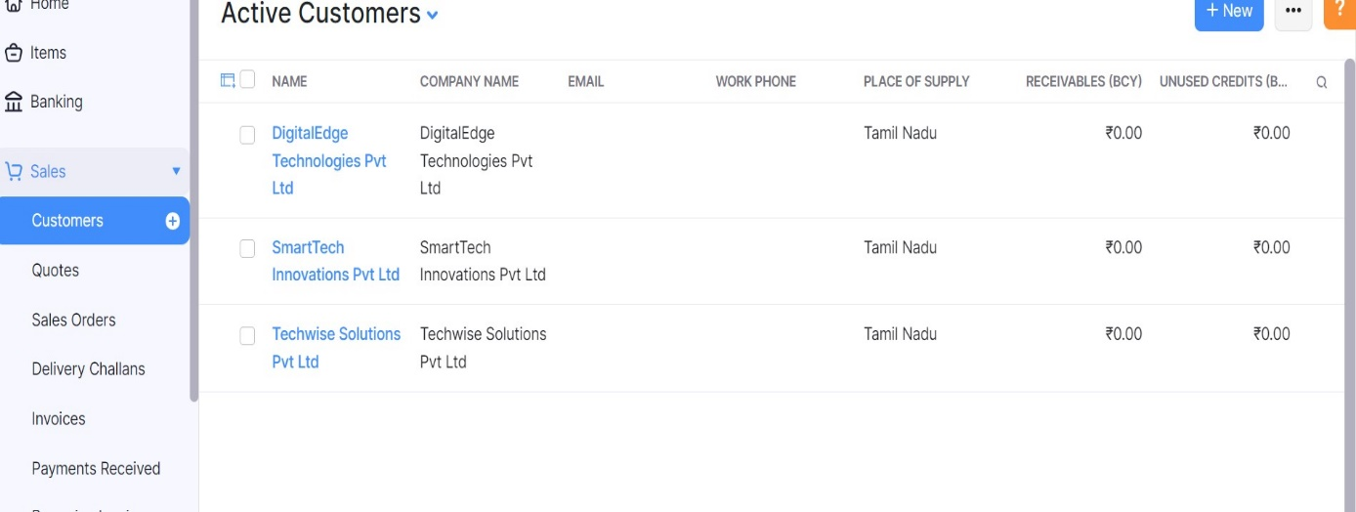
3.8. Vendors:
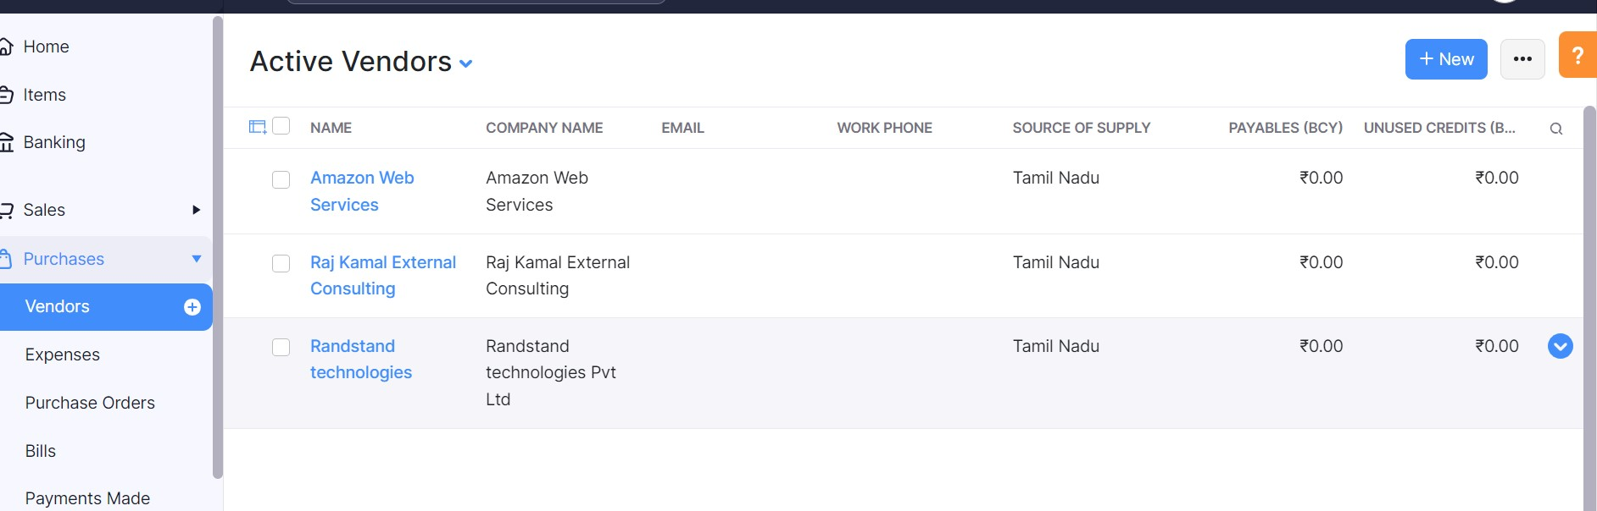
3.9. Banking:
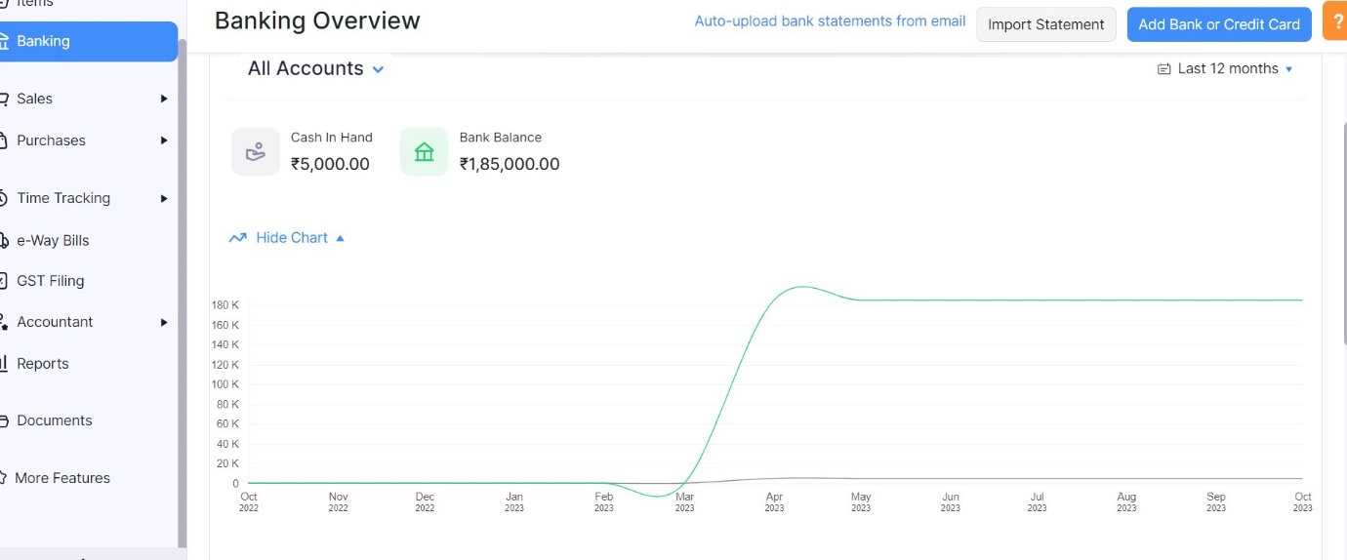
4.Advantages & Disadvantages
Advantages:
- No practice is too small or too large for us.
- Our services are customized, affordable, and designed to meet your unique needs.
- We are super creative.
- We are budget conscious.
- We are resourceful,honest,great to work with.
- Variety of work: This is why I wanted to do consulting in the first place: what you do and what client you're working for will change. How often depends on what sort of technology you work with and what your role is -- some projects take a few weeks and some take years.
- Career growth: Most consulting companies spend a lot of money on training their people; after all, the people are what they're selling. This means you can skill up on new technologies, people management skills, etc on the company's dime, which makes you both more effective and more attractive to other companies should you decide to leave some day.
- Network: Because you're working with such a wide variety of people -- both on the project teams staffed by your company and with clients -- you'll build up an impressive network very fast. As these people develop their own careers they'll be of huge help to you.
Disadvantages:
- Travel: Some people absolutely love traveling week in and week out for work. But for most of us, it quickly gets tiresome. You're generally up before the sun on Monday to catch your flight, living out of hotels, away from friends/family. And a lot of the time, you're not in some exciting city, but a boring town.
- Work/life balance: Experiences, even within a single company, will vary significantly, but it's not unusual for consultants to work terrible hours -- late nights, weekends, last minute travel plans getting cancelled.
- Turnover: Because of a) the travel and b) the work/life balance many big firms experience a fair amount of churn. People get tired of traveling, or want to start families, and move to companies where they have a more stable position. This means you'll likely lose some connections you've built up within the firm as these people leave (on the flipside, you've now got connections at other companies).

5. Applications:
It is applicable in areas such as operations, reorganization, mergers and acquisitions, or risk management.

6.Conclusion:
Conclusion summarizing the entire work and findings.
6.1. Profit & loss Report:
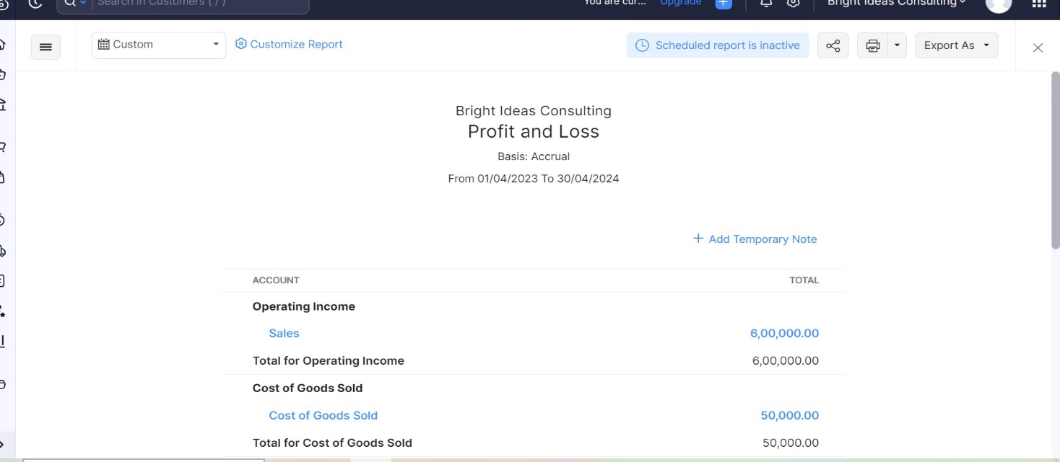

6.2. Balancesheet: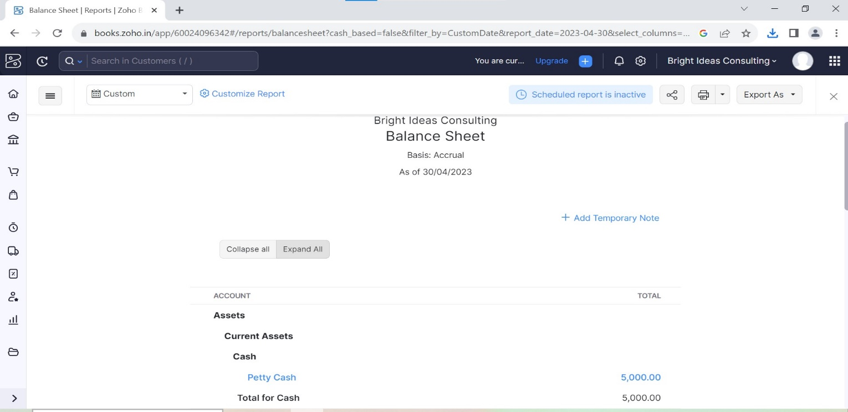

The whole project is worked on the bright ideas consulting firm where the clients are being helped the professional consultants for their reputed firms issues and sufferings. By this companies can see the improvement and growth on the whole after getting the consultations.

7.Future scope:
The totality of outputs, outcomes and benefits and the work required to produce them. In today's volatile and turbulent environment, companies are looking for more than just me-too solutions and business-as-usual processes to remain competitive. It's not enough for consultancies to keep applying "tried and trusted" methodologies that push their clients into inflexible working models.
Ultimately, the real value that consultancies need to offer is in allowing clients greater access to their experience and subject-matter expertise, whether that's through more involvement from senior partners and sector specialists or via an open consulting ecosystem and partnership network. The intelligent and agile sharing of knowledge from across markets and practices, coupled with an approach that understands both the global picture and regional specificities, as well as the ability to understand and integrate new technologies, should be central to the transformation of consulting's operating model.
The consultancy of the future needs to be an entrepreneur as well as an advisor, helping clients to realize new growth in practice, not just plan for it.

8.Appendix
Source code attach the code for the solution built

Zoho books is one stop platform for managing your accounting tasks and organizing your transactions. Its’s a single secure location to keep up with your company’s bills & invoices, reconcile your bank statements, control your spending, overseas project, & eliminates GST compliance worries
- Usability: it’s a clean & simple dashboard gives you immediate , convenient insight into your financial health. An effective, user friendly, UI makes Zoho books easy to navigate.
- Security: It protects your privacy and security with IP restrictions, two factor authentication, SSL and more’
- Reliability: It is built with dependable features that protect your data and produce accurate results for your accounting.

